

Software Requirement Specification

**Version1.1**

**Nhan Pham**

**18/11/2019**

**VERSION HISTORY**

|  |  |  |  |  |  |
| --- | --- | --- | --- | --- | --- |
| **Version #** | **Implemented**  **By** | **Revision**  **Date** | **Approved**  **By** | **Approval**  **Date** | **Reason** |
| 1.0 | Quốc Nhân | 04/11/2019 |  |  | Create Document SRS version 1.0 |
| 1.1 | Quốc Nhân | 18/11/2019 |  |  | Update Document SRS version 1.1 |
|  |  |  |  |  |  |
|  |  |  |  |  |  |

Table of Contents

1. Introduction 3

1.1 Purpose 3

1.2 Intended Audience and Reading Suggestions 3

1.3 References 3

2. Overall description 3

2.1 Function Perspective 3

2.2 Groups and Characteristics 3

2.3 Operating Environment 3

2.4 **Design and Implementation Constraints** 3

2.5 Assumptions and Dependencies 3

3. PROTOTYPES 3

3.1 Web App 3

3.2 Mobile App 3

4. USE CASES 3

5. SYSTEM FEATURES 3

5.1 Feature Perspective 3

5.2 Groups and Characteristics 3

6. data requirements 3

1.1 Data Logical Model 3

1.2 Data Dictionary 3

7. Quality attributes 3

# 

# Introduction

## Purpose

The real estate application is created by the 'Hello World' group and the file is created to determine the role, flow of user, quality attributes, functions, and data dictionary.

## ****Intended Audience and Reading Suggestions****

* Director
* Department head
* Deputy department
* Employees
* Administrator

## References



# Introduction

## Function Perspective

* Login
* Information management
* Account management
* Project management
* Statistics - report
* Business trip
* Other functions

## ****User Groups and Characteristics****

|  |  |  |
| --- | --- | --- |
| **#** | **User Groups** | **Descriptions** |
| 1 | Director | - Login/logout  - View information and search employee  - View project  - View and search statistics - report  - Register, approve and view business trip |
| 2 | Department head | - Login/logout  - View information and search employee  - View project  - View and search statistics - report  - Register, approve and view business trip |
| 3 | Deputy department | - Login/logout  - View information and search employee  - View project  - View and search statistics - report  - Register, approve and view business trip |
| 4 | Administrator | Add, edit, hide, delete, view "project, account, information, statistics - report" |
| 5 | Employees | - Login/logout  - View information and search employee  - View project  - View and search statistics - report  - Register and view business trip |

## Operating Environment

* Internet request system.
* Mobile app only supported on Android and IOS operating systems
* All data saved at real estate company

## ****Design and Implementation Constraints****

Customer:

* Easy to interact
* Optional color
* Implementation on the App Android & IOS

## Assumptions and Dependencies

* Customers provide ANDROID and IOS accounts

# Prototypes

## Web App

<https://www.figma.com/proto/GnAJTV76aVDdOMG0KjL2Tl/App?node-id=1%3A2&scaling=contain>

## **Mobile App**

<https://www.figma.com/proto/TJRUytO4xBTnot2a7ND1IM/Web?node-id=2%3A138&scaling=min-zoom>

# Use cases



# System Features

## Feature Perspective

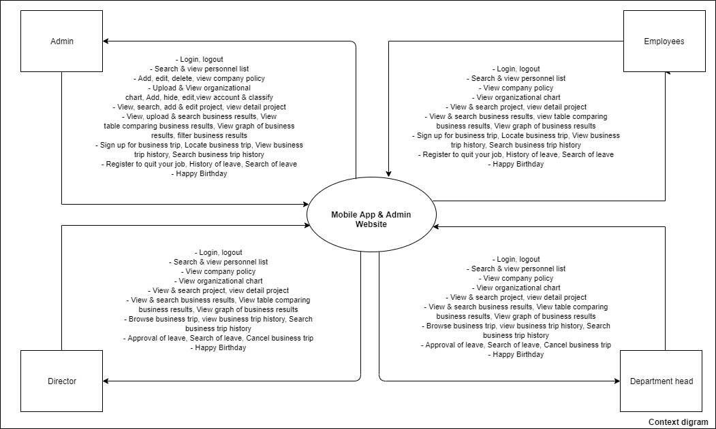

## ****User Groups and Characteristics****



# Introduction

## Data Logical Model

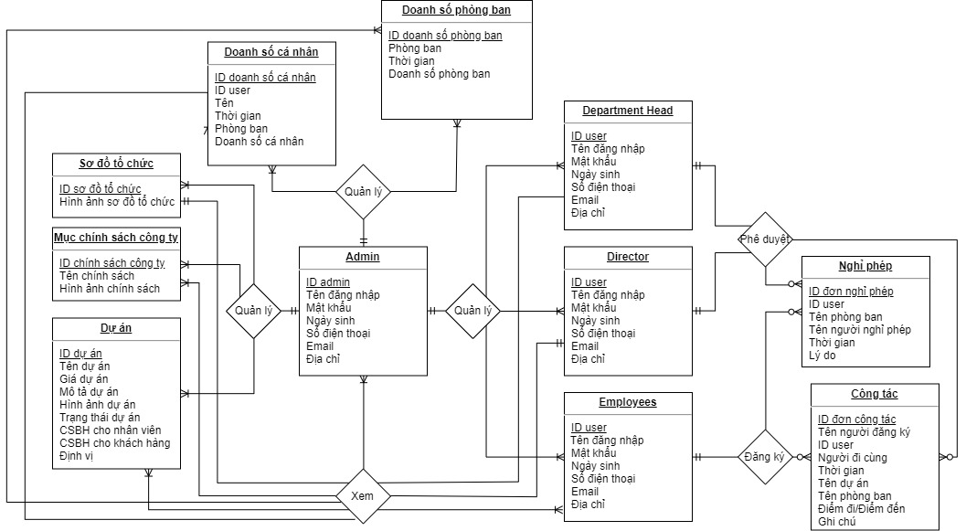

## ****Data Dictionary****



# Quality attributes.

* Usability
* Portability

|  |  |  |  |
| --- | --- | --- | --- |
| **#** | **ID** | **Quality Attributes** | **Priority** |
| **Usability** | | | |
| 1 | QA1 | Users use the app to easier | High |
| **Portability** | | | |
| 2 | QA2 | Users can use the application on two platforms | High |